Welcome to Kindergarten

Dear Parents & Students,
Hi and welcome to kindergarten. Below you will find a list of supplies you will need on your first day of school. Many of these supplies will be pooled however, supplies such as crayon pouch, pillow, blanket, headphones, and water bottle will need to have a label with your child’s name on it. Also, note that items such as sweaters and coats will need a name on the tag.
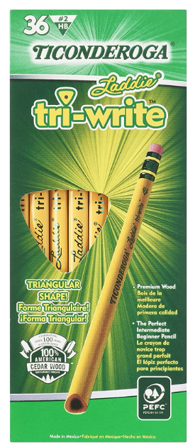
Our normal day begins at 8:00 a.m. and ends at 3:00 p.m. This year, we will be getting out of school at 2:10 on Wednesdays. When the morning bell rings, your child will line up with his or her peers and say the Pledge of Allegiance as a school. We will then enter the school as a class. If you are volunteering, please remember to sign in and to pick up a pass. Please be prompt when delivering and picking up your child. Nothing is as reassuring as a familiar face after school. If you are late, I will walk your child to the office and have them wait inside until you arrive. I am looking forward to creating many learning opportunities and memories with your child this year!
For Writing:
-One (1) box of Tri-Write pencils (24count) (You can find these on amazon)
-One (1) small box of dry erase markers

For Rest and Refocus:
-*One small pillow (Cubbies are only 8X12, regular size pillows will not fit.)
-*One small blanket

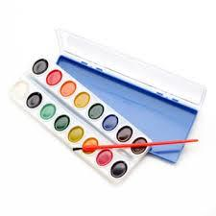
For Coloring:
-Two (2) box of crayons (24 count)
-One (1) box of colored pencils (24 count)
-One (1) box of markers (8-10 count)
- One container of watercolor paint

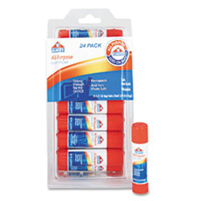
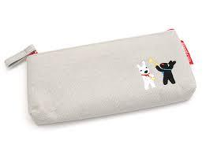
For Daily Use:
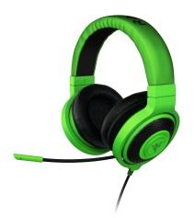
- (12) Twelve glue sticks
-*One (1) small cloth pencil or crayon pouch
- *One (1) set of headphones to stay at school (please no earbuds) Also, note that even with special care these tend to break and may need to be replaced during the year.

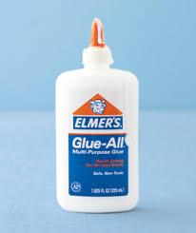
To Keep Us Healthy:
-One (1) box of tissues
-Two (2) canisters anti-bacterial wipes
-One (1) container of baby handy wipes

Lunch & Snack:
-*One (1) small reusable water bottle
-One (1) box plastic spoons (25 count)
-One (1) box plastic forks (25 count)

Please note that any items with a * next to it will need to be labeled with your child’s name.
Thank you,
Angela Crane, NBCT
Elko Institute for Academic Achievement
775-738-3422, acrane@eiaanv.net

