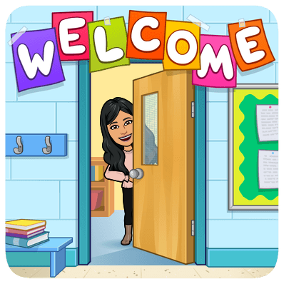
Dear Parents & Students,
Hello and welcome to First Grade! Below you will find a list of supplies you will need on your first day of school. Many of these supplies will be pooled however, supplies such as a crayon pouches, headphones, and water bottles will need to have a label with your child’s name on it. Also, note that items such as sweaters and coats will need a name on the tag.
*Items with the asterisk (*) are the items that will need student names.
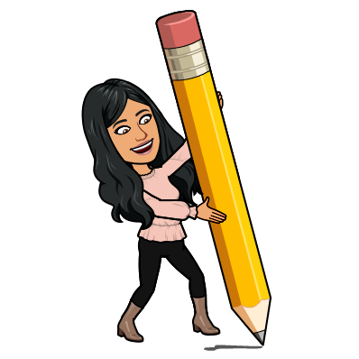
Our normal day begins at 8:00 a.m. and ends at 3:00 p.m. Please be prompt when delivering and picking up your child. Nothing is as reassuring as a familiar face after school. If you are late, I will walk your child to the office and have them wait inside until you arrive. I am looking forward to creating many learning opportunities and memories with your child this year!
For Writing:
-One (1) box of pencils (24count)
-Two (2) small boxes of dry erase markers
- One (1) package of pink erasers

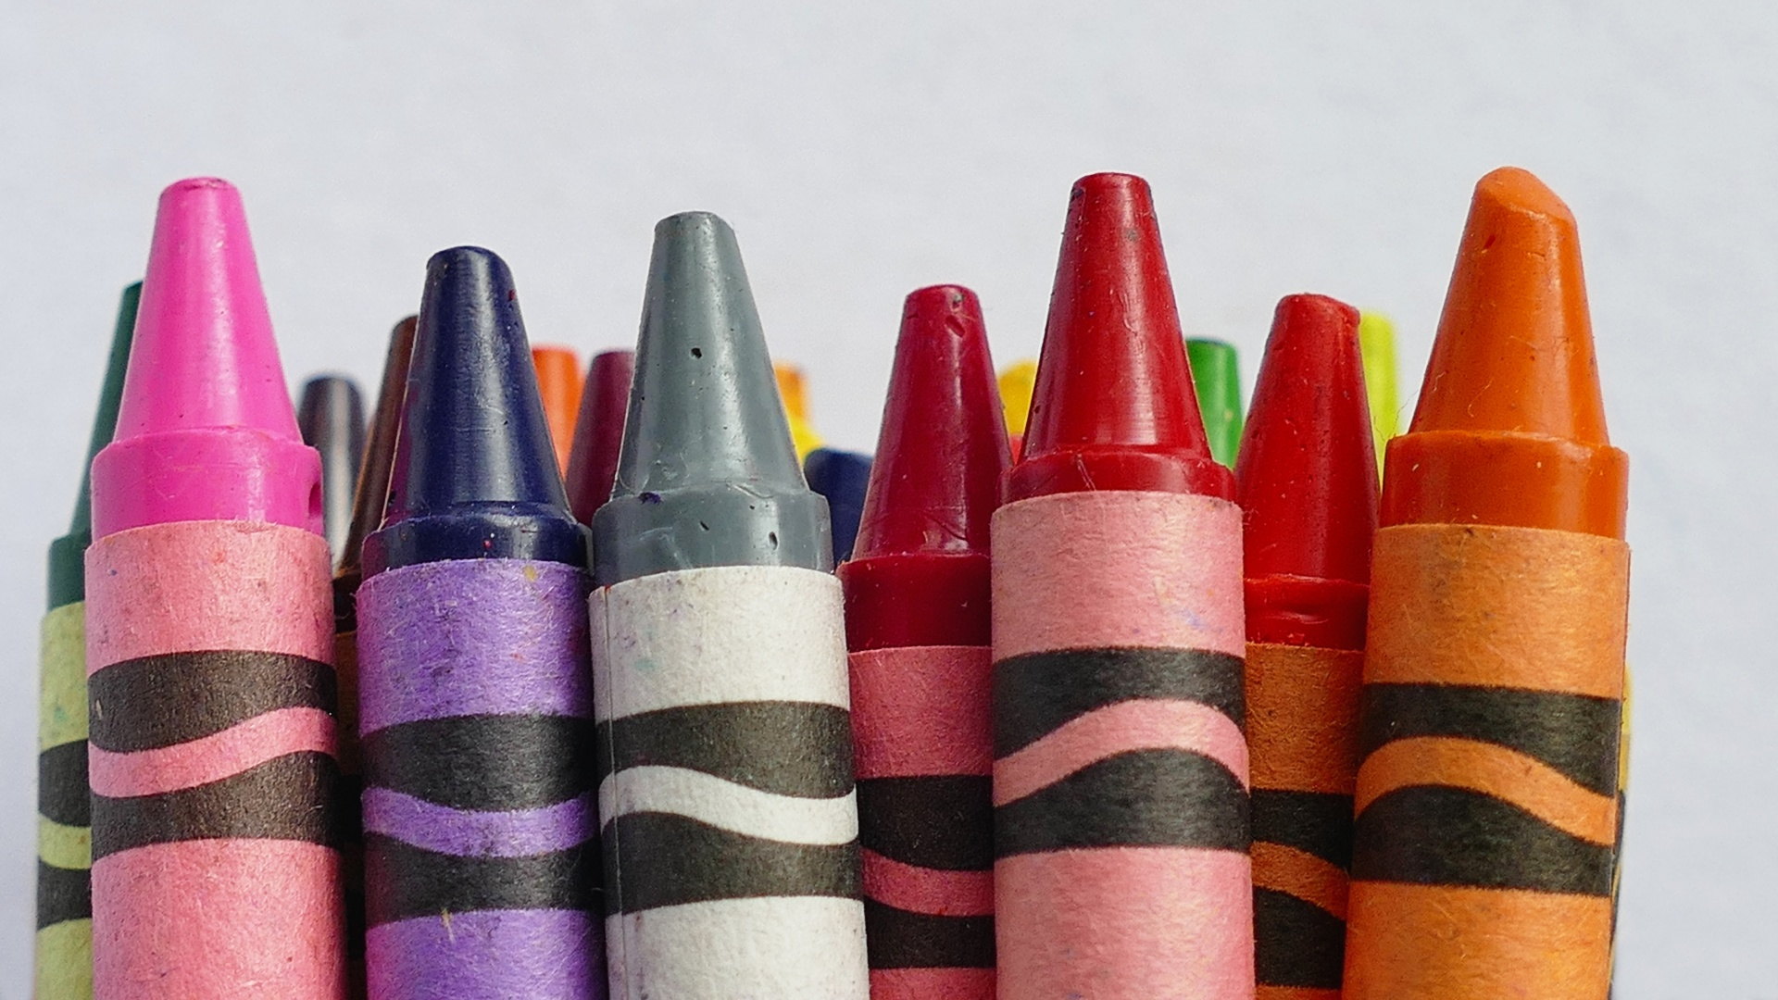
For Coloring:
-One (1) box of crayons (24 count)
-One (1) box of colored pencils (24 count)
-One (1) box of markers (8-10 count)

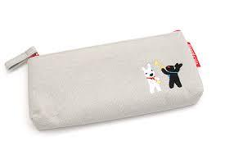

For Daily Use:
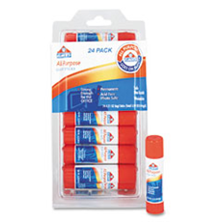
- Glue sticks
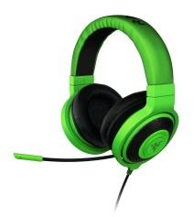
-*One (1) small cloth pencil or crayon pouch
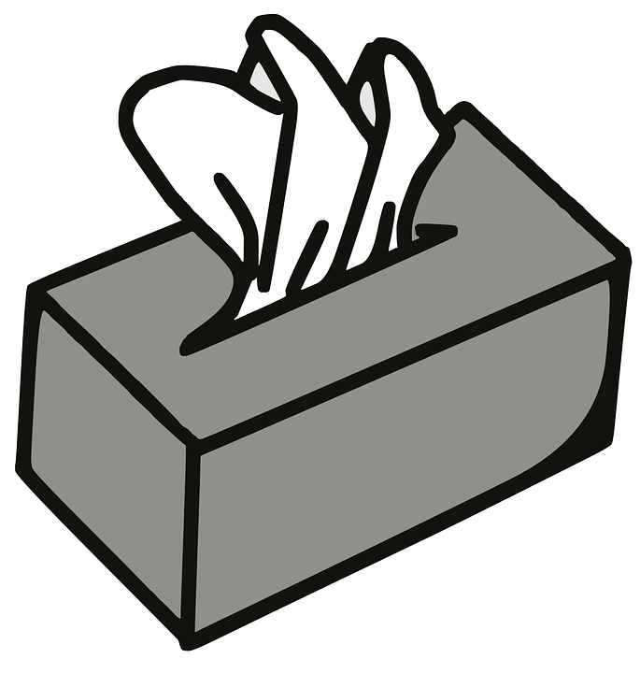
- *One (1) set of headphones (please no earbuds) Also, note that even with special care these tend to break and may need to be replaced during the year.
To Keep Us Healthy:
-three (3) boxes of tissues

Water & Snack:
-*One (1) reusable water bottle (Please have between 18oz & 24oz. small water bottle so that it will fit in their chair backs).
-We will have a time set aside for a daily snack. Please make sure they have a healthy snack in their lunch besides the normal lunch items. Thank you.

Ms. Ramirez (First Grade Teacher)
Elko Institute for Academic Achievement
775-738-3422, vramirez@eiaanv.net

