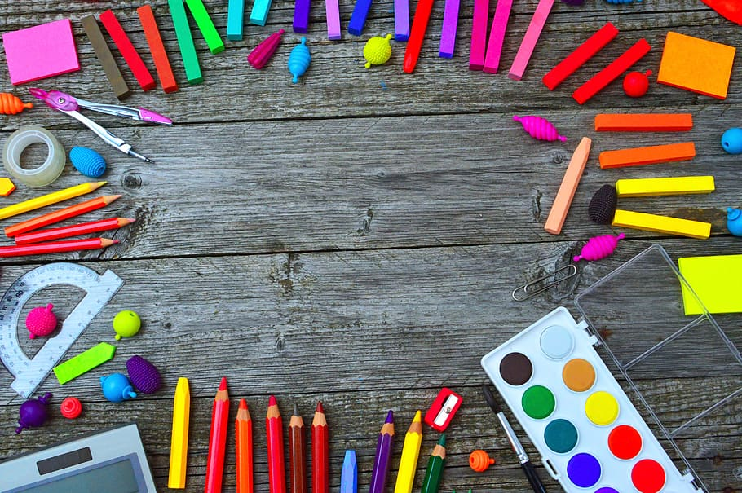
2021-2022
6th Grade Supply List
Mrs. Hepworth

I will not be allowing pens in the classroom this year. The students will use a red pen to correct assignments but no other pens please.

- 1 - 1.5 in 3 ring binders
- 2 composite notebooks
- 3 folders with pockets
- Pencils - your choice
- Highlighters
- White board markers
- Pencil box
- bottle of Hand sanitizer
- Scissors

- Red pen
- A set of Markers OR colored pencils
- Headphones
- 2 boxes of Tissues
- 2 container of Clorox wipes
- Packet of loose leaf paper - wide ruled

