Nevada Charter Authority
Elko Institute for Academic Achievement
2022-2023
School Performance Plan: A Roadmap to Success

EIAA has established its School Performance Plan for the school year. This plan was developed by the school’s continuous improvement (CI) team and informed by a comprehensive needs assessment that included data analysis and meaningful engagement with the school community. It includes the school's goals and process developed during Act 1. The CI team will monitor implementation throughout the school year and evaluate and update the goals at the end of the year.

Principal: Ashley Perkins
School Website: www.eiaanv.net
Email: aperkins@eiaanv.net
Phone: 775-738-3422
School Designations: XTitle I ☐CSI ☐TSI ☐ TSI/ATSI

Our SPP was last updated on 11/10/2022.

School Continuous Improvement Team
The Continuous Improvement Team is made up of a diverse group of school administrators, teachers, staff, caretakers, and students charged with developing, implementing, and evaluating the school’s continuous improvement efforts outlined in the School Performance Plan.
Name | Role
Ashley Perkins | Principal(s) (required)
Lori Lynch VP | Other School Administrator(s) (required
All Staff | Teacher(s) (required)
All Paraprofessionals | Paraprofessional(s) (required)
All parents have been a part of the process through conferences, surveys, and direct feedback | Parent(s) (required)
All students have been a part of the process through surveys, data chats, goal setting, and direct feedback | Student(s) (required for secondary schools)
 | Tribes/Tribal Orgs (if present in community)
RTB data, NNRPDP | Specialized Instructional Support Personnel (if appropriate)
Add additional members/roles as necessary

School Demographics and Performance Information
In compliance with federal and state law, Nevada’s K-12 Accountability Portal provides detailed information about each school’s student and staff demographics and school performance rating, a star-rating system based on the Nevada School Performance Framework (NSPF). You can find our School Rating Report at http://nevadareportcard.nv.gov/di/report/summary_1?report=summary_1&scope=e24.y19&organization=c26537&scores=MA_level%2CRD_level%2CMA_NotTested%2CRD_NotTested%2CMA_pass%2CRD_pass%2CMA_Tested%2CRD_Tested%2CN_MA%2CN_RD&num=20&page=1&pagesize=20&domain=assessment&

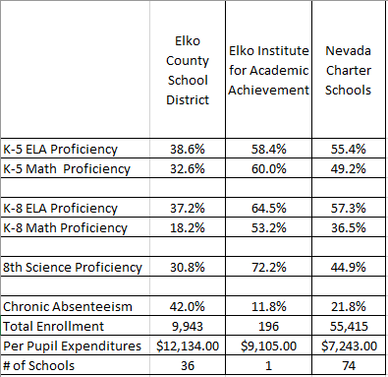

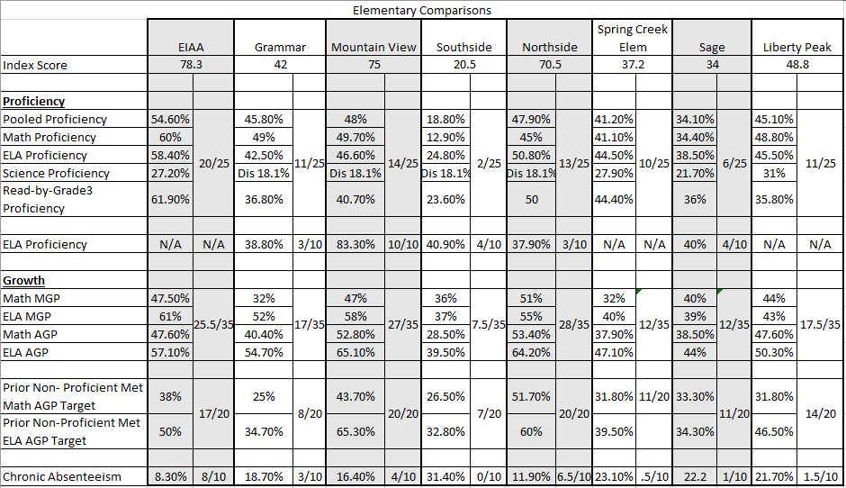

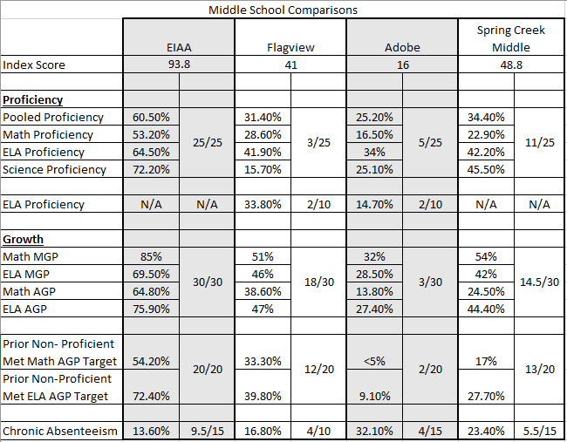

School Goals and Improvement Plan
The improvement plan on the following pages articulates our goals for the upcoming school year, strategies we will employ to achieve our goals, and other important planning information.

Inquiry Area 1 - Student Success
Student Success
Areas of Strength | Areas for Growth
- Update after School Data Dive. | - Update after School Data Dive.
Problem Statement: Analyzing data and collaborating with staff, we have identified Student Agency as our target for improvement. We have identified student agency as “The capacity to set a goal, reflect and act responsibly to effect change. It is about acting rather than being acted upon; shaping rather than being shaped; and making responsible decisions and choices rather than accepting those determined by others.

Critical Root Causes of the Problem:
- Clarity of learning goals for the lesson, Why they are learning it, and what successful performance looks like ultimately leading to student responsibility for learning and agency over learning.

Student Success
School Goal: EIAA’s Goal for the 2022-2023 school year is to have at least a 50 for our MGP growth for both ELA and Math and a 50 AGP for growth for both ELA and Math  Formative Measures:  - Classroom Assessments, I-ready, MAP | Aligned to Nevada’s STIP Goal:  ☐ STIP Goal 1 X STIP Goal 2  X STIP Goal 3 ☐ STIP Goal 4  ☐ STIP Goal 5

Improvement Strategy:  * Hire 3rd party data consultant to help EIAA analyze data and identify areas of need.  *Identify each students’ strengths and deficits based on student data.  *Create individual student, data-based objectives and goals based off student’s identified strengths and deficits.  * Bring the students in to help identify goals and objectives.  *Use evidence-based interventions such as Newsela, Odyssey Math, Odyssey Reading, I-ready, DRA and data based decision making to create a plan, instruction, and practice based off goals and objectives.  Evidence Level: What Works Clearinghouse puts plan and interventions at levels 3 and 4.  https://www.wallacefoundation.org/knowledge-center/Documents/Social-and-Emotional-Learning-Interventions-Under-ESSA.pdf  https://intensiveintervention.org/tools-charts/levels-intervention-evidence  Action Steps:  - Align financial resources to cover cost of data consultant and intervention supplies and personnel  - Hire Data Consultant  - Sign agreement for I-ready and Intervention Programs  - Hire Instructional Aide  - Identify Big Rocks  - Create and manage student leadership binders  - Work with teachers of record to set up weekly push in schedule/tracker.  - Have teachers identify what success looks like for students working with resource teacher  - Communicate student needs with parents  - Monitor and adjust student instruction and interventions based on data  Provide PD in Formative Assessments and Number Talks  Resources Needed: What resources do you need to implement this improvement strategy?  - Budget for data consultant / instructional aide / I-ready  - Recruitment and hiring plan  - Big Rocks for Grade levels  Student Leadership binders identifying student data, student need, and interventions with plan moving forward  Challenges to Tackle:  - Finding financial resources given limited budget  - Keeping interventions and instruction moving at a rapid pace to see big growth.  - Time for teachers and instructional aide to meet to ensure quality plan and instruction.  Funding: What funding sources can you use to pay for this improvement strategy(ies) associated with this goal?  - ARP Funding  - Title I  - SPED  - General Budget | Lead: Who is responsible for implementing this strategy?  Update after Strategy Selection

Resource Equity Supports: Based on your Data Dive and Root Cause Analysis, what if any resource inequities did you identify for the following student groups specific to this goal? (Consider any challenges these groups face.) What, specifically, will you do to support them to overcome these challenges?
English Learners: Track formative data to measure if any disparities exist during intervention. Using research-based instruction for ELL.

Foster/Homeless: Track formative data to measure if any disparities exist during intervention. Clear communication with Guardians.

Free and Reduced Lunch: Track formative data to measure if any disparities exist during intervention.

Migrant: Track formative data to measure if any disparities exist during intervention.

Racial/Ethnic Minorities: Track formative data to measure if any disparities exist during intervention.

Students with IEPs: Track formative data to measure if any disparities exist during intervention. Closely monitoring and tracking IEP goals and success criteria.

Inquiry Area 2 - Adult Learning Culture
Adult Learning Culture
Areas of Strength | Areas for Growth
- Having a strong belief that All children can learn and making learning relevant | - Aligning assessments to goals and creating learning tasks with high-cognitive demand.
Problem Statement: Student Proficiency Levels are not where we want them to be.

Critical Root Causes of the Problem:
- Analyzing data, Defining big rocks in grade level, Determining student needs, Implementing strategic and focused research based interventions, Improving tier 1 instruction

Adult Learning Culture
School Goal: By the end of November teachers will have created individual goals that align with our school goals.  By the end of December, teachers will have an individual PD plan to work with NNRPDP.  Formative Measures:  - Teacher Goals and Plans | Aligned to Nevada’s STIP Goal:  ☐ STIP Goal 1 X STIP Goal 2  X STIP Goal 3 ☐ STIP Goal 4  ☐ STIP Goal 5

Improvement Strategy: Teachers will work with PDP to set individual goals aligning with school goal. Individual PD plan will be created.  Evidence Level:  Providing quality research-based PD in Formative assessment and number talks falls in tier 3 of ESSA Evidence.  https://www.nctm.org/Research-and-Advocacy/research-brief-and-clips/Benefits-of-Formative-Assessment/  Action Steps: What steps do you need to take to implement this improvement strategy?  - Contact NNRPDP to set up Professional Development with staff to set foals and create plans  - Schedule time for each teacher to meet with coach (Modeling, feedback, coaching)  Resources Needed: What resources do you need to implement this improvement strategy?  - PD Professionals  - Time  Challenges to Tackle: What implementation challenges do you anticipate What are the potential solutions?  - Implementation Challenge: Implementing best practices into teaching  - Potential Solution: PD  Funding: What funding sources can you use to pay for this improvement strategy(ies) associated with this goal?  - Title 1  - ARP Funding  - SPED  - General budget | Lead: Who is responsible for implementing this strategy?  All staff play a role

Resource Equity Supports: Based on your Data Dive and Root Cause Analysis, what if any resource inequities did you identify for the following student groups specific to this goal? (Consider any challenges these groups face.) What, specifically, will you do to support them to overcome these challenges?
English Learners: Track formative data to measure if any disparities exist during intervention. Using research-based instruction for ELL.

Foster/Homeless: Track formative data to measure if any disparities exist during intervention. Clear communication with Guardians.

Free and Reduced Lunch: Track formative data to measure if any disparities exist during intervention.

Migrant: Track formative data to measure if any disparities exist during intervention.

Racial/Ethnic Minorities: Track formative data to measure if any disparities exist during intervention.

Students with IEPs: Track formative data to measure if any disparities exist during intervention. Closely monitoring and tracking IEP goals and success criteria.

Inquiry Area 3 - Connectedness
Connectedness
Areas of Strength | Areas for Growth
- Strength: 82% of 5-8th graders surveyed agree or strongly agree that they feel like they are “part of this school”, while 18% disagree or strongly disagree. | - Keeping parents updated on student learning goals.
Problem Statement: Families need to know what students’ learning goals are, why they are learning it, what success looks like, and what their role is.

Critical Root Causes of the Problem:
- Time

Connectedness
School Goal: EIAA will have 3 sets of parent teacher conferences throughout the year updating parents on student present levels and goals.  EIAA will share student state data with parents including MAP updates, I-ready updates, and SBAC results.  Formative Measures:  - Parent Conference Numbers  - Presenting Data to parents | Aligned to Nevada’s STIP Goal:  ☐ STIP Goal 1 ☐ STIP Goal 2  XSTIP Goal 3 ☐ STIP Goal 4  ☐ STIP Goal 5 X STIP Goal 6

Improvement Strategy: Communicate with parents on a regular basis. Share specific data and intervention plans to get students where we need them.  Evidence Level: Unable to find an exact level connecting ESSA and family engagement. They do however say the evidence is consistent and convincing: Families have a major influence on their children’s achievement in school and in life. When schools, families, and community groups work together to support learning, children tend to do better in school, stay in school longer, and like school more. (For examples of evidence, visit U.S. Department of Education’s What Works Clearinghouse, https://ies.ed.gov/ncee/wwc/ReviewedStudies/#/Keyword:parent%20involvement%7COnlyStudiesWithPositiveEffects:false%7CSetNumber:1%7CEssaRatingId:  Action Steps: What steps do you need to take to implement this improvement strategy?  - Set up parent teacher conferences  - Ensure student data is printed and shared with parents as results and updates come in.  Resources Needed: What resources do you need to implement this improvement strategy?  - Leadership binders  - Time to meet with parents  Challenges to Tackle:  Getting parents to understand student current levels and how they can help support student goals at home.  Funding:  Title 1  SPED  ARP ESSER  General Budget | Lead: Who is responsible for implementing this strategy?  Update after Strategy Selection

Resource Equity Supports: Based on your Data Dive and Root Cause Analysis, what if any resource inequities did you identify for the following student groups specific to this goal? (Consider any challenges these groups face.) What, specifically, will you do to support them to overcome these challenges?
English Learners: Track formative data to measure if any disparities exist during intervention. Using research-based instruction for ELL.

Foster/Homeless: Track formative data to measure if any disparities exist during intervention. Clear communication with Guardians.

Free and Reduced Lunch: Track formative data to measure if any disparities exist during intervention.

Migrant: Track formative data to measure if any disparities exist during intervention.

Racial/Ethnic Minorities: Track formative data to measure if any disparities exist during intervention.

Students with IEPs: Track formative data to measure if any disparities exist during intervention. Closely monitoring and tracking IEP goals and success criteria.

School Community Outreach
This section highlights our school’s deliberate and strategic efforts to engage the broader school community in our continuous improvement efforts by keeping them informed on our progress and learning and eliciting their feedback and perspective.
Outreach Activity | Date | Lessons Learned from the School Community
EIAA works with many members in the community from the power company to local business to the local VFW and a lot of people in between | Ongoing and frequent throughout the year | - Math  - ELA  - Science  - Life Skills  - College and Career Readiness.

“Resource equity” is the allocation and use of resources – people, time, and money – to create student experiences that enable all children to reach empowering, rigorous learning outcomes, no matter their background. (Definition adapted from USED)

